- How to draw “Branch Line Coupler”
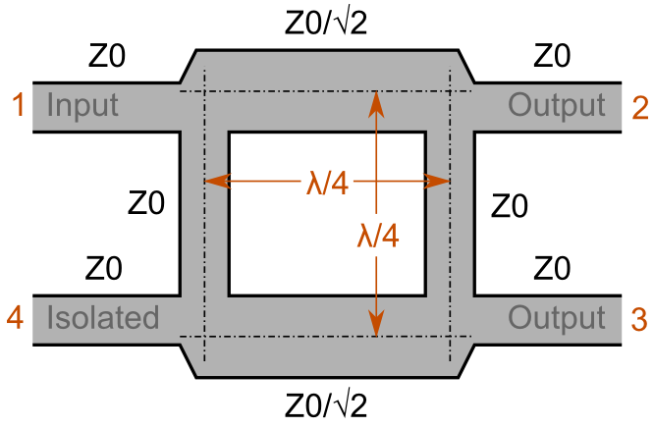
Assumed that: Z₀ = 50 Ω has transmission line width 2.42 mm
Z₀/√2 = 35.35 Ω has transmission line width 3.95 mm
λ/4 = 30mm
50 Ω transmission line for port connection, L = 5 mm and W = 2.42 mm
- So we can draw the “Branch Line Coupler” on AutoCAD as below:
- Draw 50 Ω transmission line with width and length above then copy and paste to get two stub.
- Draw 35.35 Ω transmission line with width and length above then copy and paste to get two stub.
- Select the stub that you want to move then type “m” + “Enter” and move from the center point of the width.
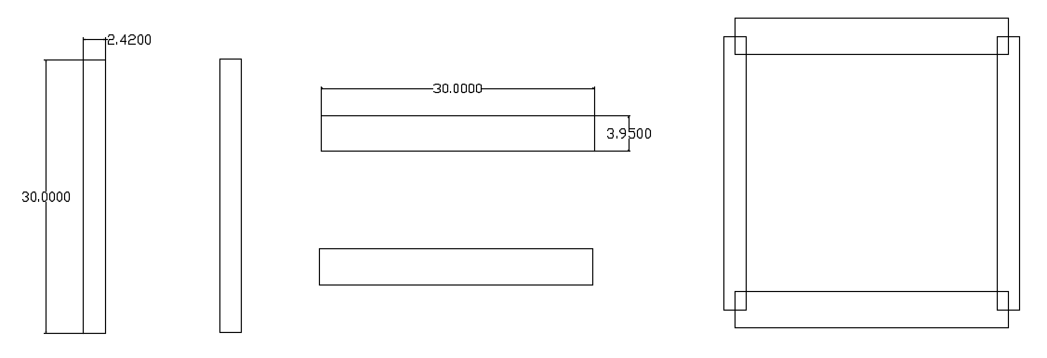
(1) (2) (3)
- Draw 50 Ω transmission line for port connection (5mm)
- To cut the cross line we use comment: “tr” + “Enter” then click on the line that you want to remove.
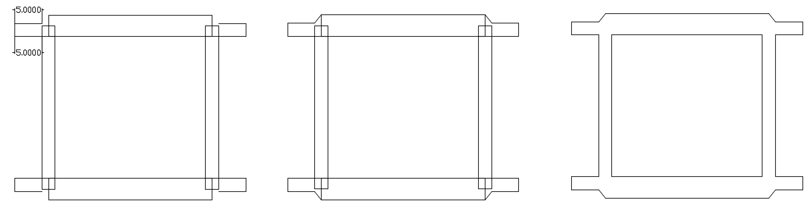
(4)
- Draw the PCB border (use Poly line).
- To reduce the etching time we can hatch some part of copper on PCB except circuit part. Noted that, black part will remove during etching process.
- To hatch the remove part you can you comment: “h” + “Enter”, chose the “Black” color.
- The remove part along the transmission line (width of black part) must be greater than 1mm.
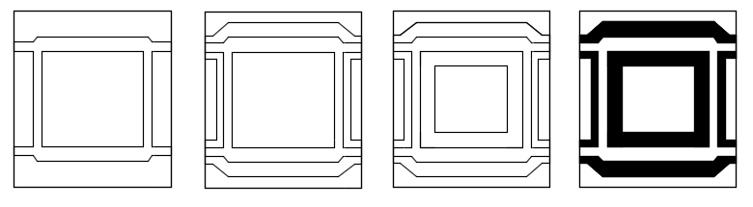
(5) (6)
- Select all the lines on the PCB then remove them.
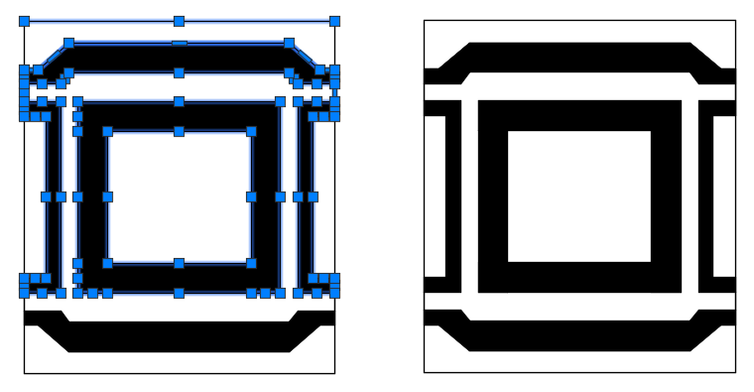

- How to draw “Ring Hybrid”
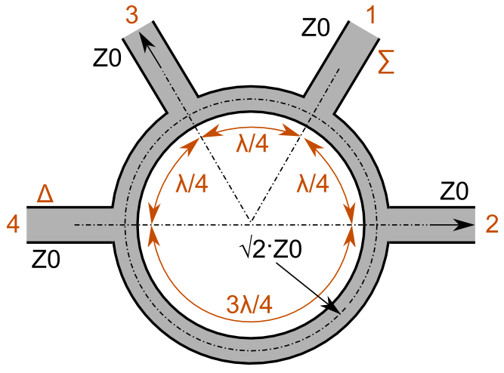
Assumed that: Z₀ = 50 Ω has transmission line width 2.42 mm
Z₀√2 = 70.71 Ω has transmission line width 1.7 mm
λ/4 = 30mm
50 Ω transmission line for port connection, L = 5 mm and W = 2.42 mm
- The circumference of the reference circle is 6λ/4 = 180 mm, so the radius r = 28.66 mm. Let draw a circle with r₁ = r-1.7/2 =28.66 mm - 0.85 mm = 27.81 mm.
- Draw a new circle with r₂ = r+1.7/2 =28.66 mm + 0.85 mm = 29.51 mm.
- Draw the reference line on the circle.
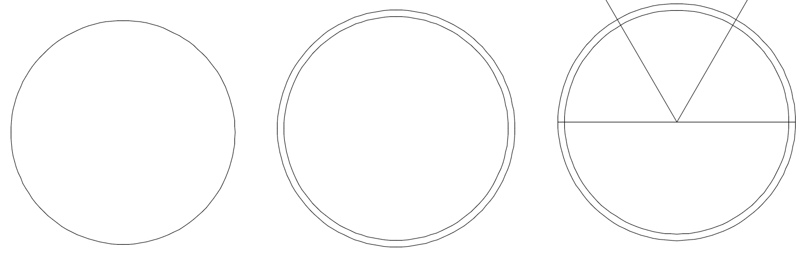
- (2) (3)
- Draw the stub with length, L = r₂ + 5mm=34.51mm and width, W = 2.42 mm from the center point.
- Copy and paste that stub to get 3 more. Rotate 2 of stub with 60 degree and 120 degree.
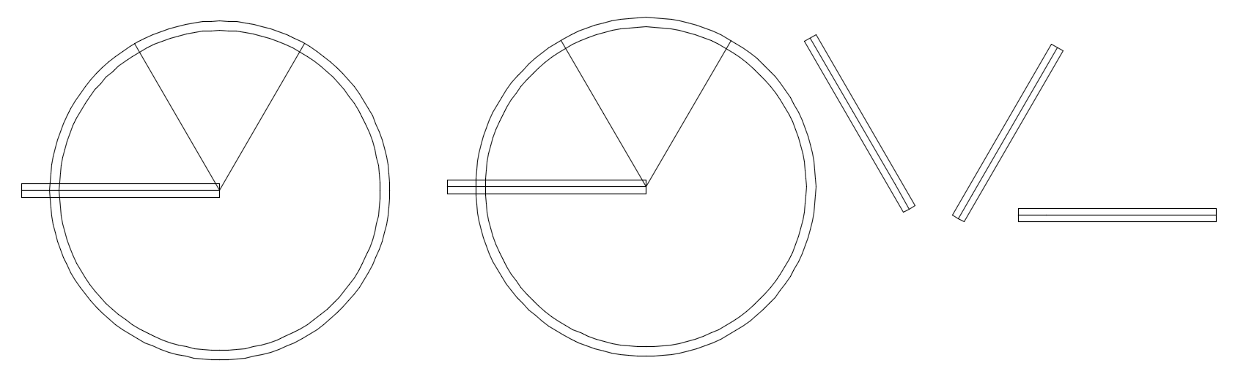
(4) (5)
- Move all start points of the stubs to the center point of the circle.

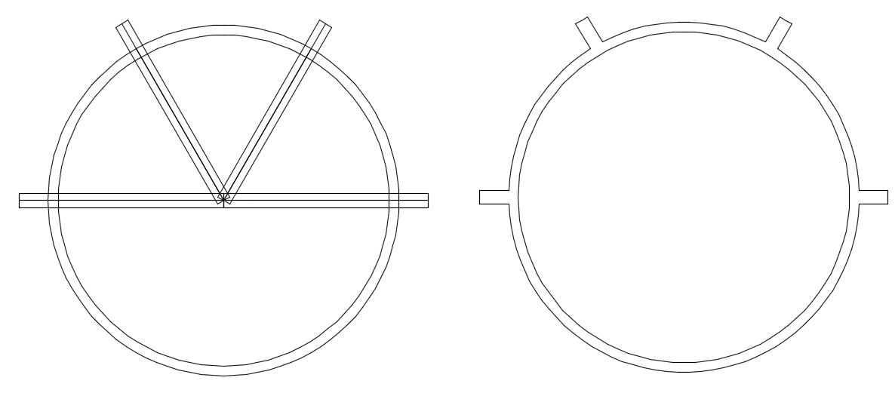
(6)

- Draw the PCB border (use poly line) and the area that you want to remove copper.
- Use comment “tr” + “Enter” to remove cross line.
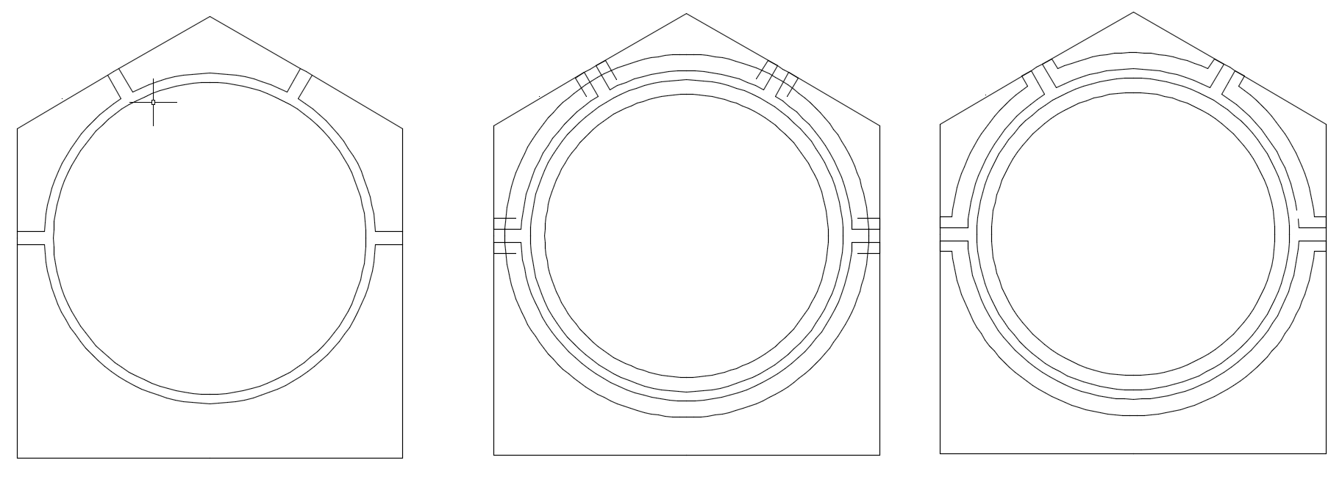
(7)
- Hatch the remove part. “h” + “Enter”
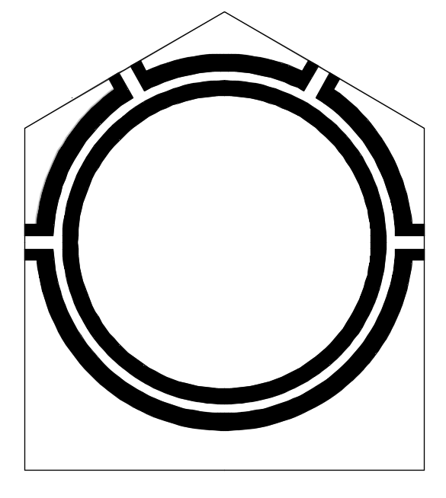
- Remove all line on pattern.
